|  |
| --- |
| VITlogo_normal.jpg |
| ITSU3008  Project 1  Final Report |
|  |

**Submitted To:**  **Submitted By:**

Arash Fereidouni Sushant Kumar Jaiswal

Unit Coordinator Student ID: 40468

BITS Date: 24/10/2020

Table of Contents

[Table of Contents 1](#_Toc54915774)

[*Abstract* 3](#_Toc54915775)

[Introduction 3](#_Toc54915776)

[Literature Review 4](#_Toc54915777)

[Gantt Chart 6](#_Toc54915778)

[Budgeting 7](#_Toc54915779)

[Expenses 7](#_Toc54915780)

[Hardware Requirements and Software Requirements 9](#_Toc54915781)

[Hardware Requirements 9](#_Toc54915782)

[Arduino UNO 9](#_Toc54915783)

[Ultrasonic sensor HC-SR04 9](#_Toc54915784)

[Servo Motors 10](#_Toc54915785)

[Voltage Regulator 11](#_Toc54915786)

[Software Requirements 12](#_Toc54915787)

[Using Arduino Software 12](#_Toc54915788)

[Functional Requirements & Non-Functional Requirements 13](#_Toc54915789)

[Functional Requirements 13](#_Toc54915790)

[Automatic Detection and Tracking 13](#_Toc54915791)

[Coverage 13](#_Toc54915792)

[Picking up Signal 14](#_Toc54915793)

[Frequency 14](#_Toc54915794)

[Non-Functional Requirements 15](#_Toc54915795)

[Reliability 15](#_Toc54915796)

[Performance 15](#_Toc54915797)

[Security 15](#_Toc54915798)

[Usability 15](#_Toc54915799)

[Methodology 16](#_Toc54915800)

[Agile 16](#_Toc54915801)

[Kanban 17](#_Toc54915802)

[Scope 19](#_Toc54915803)

[Product Scope Description 19](#_Toc54915804)

[Deliverables 19](#_Toc54915805)

[Acceptance Criteria 19](#_Toc54915806)

[Project Exclusions 19](#_Toc54915807)

[Constraints: 19](#_Toc54915808)

[Project Assumptions 19](#_Toc54915809)

[Feasibility Analysis 20](#_Toc54915810)

[Technical Feasibility 20](#_Toc54915811)

[Operational Feasibility 20](#_Toc54915812)

[Legal Feasibility 20](#_Toc54915813)

[Economical Feasibility 21](#_Toc54915814)

[Risk Constraints Analysis 22](#_Toc54915815)

[Budget 22](#_Toc54915816)

[Policy 22](#_Toc54915817)

[Scope Creep 22](#_Toc54915818)

[Safety 22](#_Toc54915819)

[Scope 22](#_Toc54915820)

[Time 22](#_Toc54915821)

[Training 22](#_Toc54915822)

[UML diagram and descriptions 23](#_Toc54915823)

[Use Case Diagram 23](#_Toc54915824)

[Class Diagram for GUI sub-system 24](#_Toc54915825)

[Class Diagram 25](#_Toc54915826)

[Executive Summary 26](#_Toc54915827)

[Social Aspect 26](#_Toc54915828)

[Ethical Aspect 26](#_Toc54915829)

[Architectural Diagram 27](#_Toc54915830)

[Flow Chart 28](#_Toc54915831)

[Project Flow Chart 28](#_Toc54915832)

[System Flow Chart 33](#_Toc54915833)

[Circuit Diagram 34](#_Toc54915834)

[Block Diagram 35](#_Toc54915835)

[Conclusion 36](#_Toc54915836)

[References 37](#_Toc54915837)

[Appendix 39](#_Toc54915838)

[Appendix A (Assignment 1) 39](#_Toc54915839)

[Appendix B (Assignment 2) 40](#_Toc54915840)

[Appendix C (Assignment 3): 41](#_Toc54915841)

Ultra-Sonic Radar Detection

*Abstract* ***-***A radar detector is an electromechanical instrument used by drivers to identify whether their pace is tracked by the security forces or by police authorities using a speed gun. The radar dish or antenna communicates pulses of radio signals or microwaves that rattle off any object in its path. Arduino is a single-board microcontroller designed to make the use of electronics more readily available in addition to its impact. The aim of this project is to make a RADAR that is efficient, cheaper and reflects all the possible techniques that a radar comprises.

# Introduction

RADAR is an activity identification system that uses radio waves to assess product size, height, bearing, or distance. Radar systems come in a number of sizes and have guiding determinations of implementation. Few radar systems are used at air terminals for the aviation authority and others are used for distanced surveillance and early-cautionary systems. A radar frame is the centre of a racket steering system. Small handy radar systems that one person can keep up and operate on are accessible much like systems that occupy a few big rooms. [1]

Radar had developed furtively by a few nations before and after the Second World War. U.S. Navy adopted the term RADAR itself, not the true turn of events, in 1940 as an abbreviation for Radio detecting and Ranging.

Exceptionally diverse are the leading edge applications of radar, including airport surveillance, astronomy, cosmology, air-guard frameworks, antimissile frameworks, antimissile frameworks; naval radars to locate landmarks and various boats; aircraft toward crash frames; Marine identification systems, spatial assessment and coordination systems; meteorological weather checks; weather altimetry and flight control checks; altimetry and air traffic control frameworks; aim driven rocket finding frameworks; And surface radar for spatial interpretations. Cutting edge radar systems enable advanced sign preparation and are configured to untangle valuable high prevalence data. [1]

# Literature Review

Since reviewing a segment of the articles on the use of ultrasonic sensors and ARDUINO, it was discovered that this concept was checked a lot and that it was a popular notion that was already in advance. The advancements used were not only efficient and strong, but also financially feasible [1]. Not just this, other very useful uses of ultrasonic sensors have also been observed.

This paper [2] explores a tracking device developed to calculate the speed of waves and the height of the river using an ultrasonic sensor using a micro-controller (Arduino). If there is a risk that the water can't push the amount of water, so all the water will drench with the ground and this event is considered a flood or a wave. We can solve this flood issue by first recognising the height of the water and by monitoring the intensity. If we define the problem sooner, we can solve the problem until it becomes a disaster. By measuring the device, i.e. a basic water volume, it was found that the ultra-sonic accuracy was 96.6 per cent. But when applied in rivers, there are numerous mistakes due to varying forms of water levels due to high waves and water velocity, and also due to the floating of high artefacts. In comparison to earlier test results, the author directed this study to monitor the pace of change or alteration of water and the amount of water in floods. The test was performed while the Arduino was used as a software processor. For further analysis, the system's depth and water speed details will be submitted to the database server website to be reviewed regularly [2].

Intelligent driver tracking and traffic control systems are incorporated in this study. This technology is intended to deter collisions by tracking the actions of the driver. The writer points to a few of the key causes of injuries today. These involve alcohol use by the driver, lack of treatment, somnolence or mental disorder. Various units within the system, including generators, relays, control units and the ESP8299 module, are tested and observed to be in working order. Ultrasonic sensor is used to warn the driver if a car is positioned next to the car. The state of the driver can be monitored by the aid of sensors carried out in the automobile and the subtle elements are updated by the manager. This method overcomes all the various aspects caused by the failure of other technologies developed for this reason, making the process very effective, powerful and less expensive and time-consuming [3].

In this research paper, the authors presented details on the identification of radio signals and monitoring or filtering through a radar package consisting of modules such as an ultrasonic sensor, a servo motor and an Arduino. The author addressed the issue of linear measuring, owing to which data structure between certain objects was not feasible, with the invention of an Ultrasonic distance metre. It requires contact - free measurements to be made. This radar system will reduce the energy consumption significantly. The author says that such a device is an incredibly convenient radar system which can interpret or record the distance and angle of the obstruction and view it on the computer screen. The ultra-sonic was mounted to the top of the servo-motor to sense obstacles at 0 degrees to 180 degrees from right to left. Both the ultrasonic sensor and the servo were powered and operated by the Arduino controller. The GUI was designed using the JAVA programming language to represent the outcome on the computer. [4]

This article [5] is a method for the identification of obstacles in a defined place. This device operates for an Android-based handheld camera. People who are partially blind face challenges in finding obstacles and moving while driving. They have handles for this issue, but this method is not the best way to do it. Object sensor or tracker may solve people's injuries or crash issues or the other approach is for correct map interpretation.

The technique suggested in this paper is optimised for indoor navigation. Both identifiable surfaces are taken into account indoor surroundings and a single picture is preserved or processed for distinctive floors. This floor photographs are taken as a source image. The author points out that this algorithm is 96 percent reliable and operates in real time. Various methods for the identification of obstacles are explored in this article. For such types of issues, we could use the method of the SONAR sensor and even the laser camera. In this article, a measurement was made for the detection of obstacle in known condition with an android-based flexible camera scanning the specified region until the camera for the position of the obstacle. [5]

This research [6] is all about a blind walking stick designed for visually impaired people, in which they can escape hurdles while moving and understanding currency. With the thinking of visually disabled people, it is, to a certain extent, difficult to discern cash or another unforeseen barrier. While it is possible to understand the size-dependent currency, it is relatively difficult to discern whether the note is special or phonetic.

The authors have developed the Currency Recognition Blind Walking Stick to address this problem. Most work is being conducted on currency identification and object tracking using sophisticated technology such as optical character recognition, SURF and colour variation retrieval. But neither of those devices had an object tracking function for blind people. This system is thus effective like those with an additional function to support the visually impaired. [6]

# Gantt Chart

The given Gantt chart (Fig 1 & 1.5) is a simple viewpoint after some time on the tasks planned. This map is used to coordinate all items being fair for undertakings and a convenient way of showing what work is expected to be completed on a given day / week. In one basic view, they also assist us in surveying the start and end dates of a venture.

**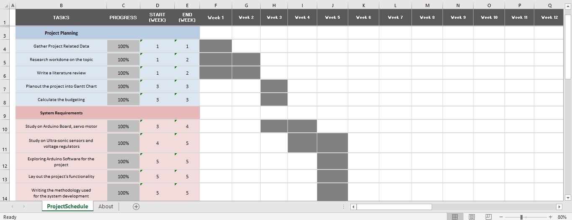**

Fig 1: Gantt Chart for Phase 1 & 2 of the project

**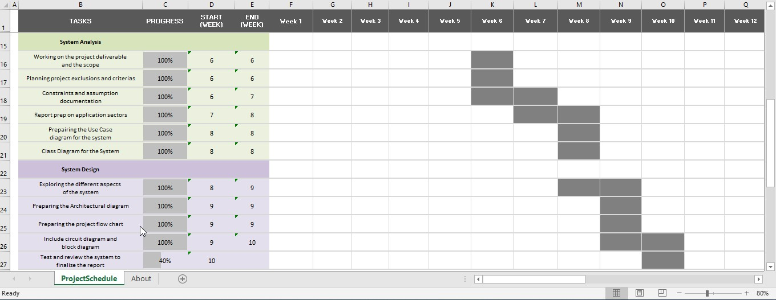**

Fig 1.5: Gantt Chart for Phase 3 & 4 of the project

# Budgeting

This report describes necessary Radar Detection related costs project which I chose due to its vast implication fields. The total cost for the project has been itemized in this detailed budgeting section for each cost element.

Given the nature and size of the output required, the project is finished in 12 weeks, starting from scratch.

## Expenses

Given are the essential expenses of the project:

* Direct Labour - Nil
* Equipment & Materials

|  |  |  |  |
| --- | --- | --- | --- |
| Item Description | Quantity | Unit Price | Extended Price |
| Arduino Uno | 1 | A$ 35 | A$ 35 |
| Bread Board | 1 | A$ 8 | A$ 8 |
| Ultrasonic Sensor | 1 | A$ 5 | A$5 |
| Micro Servo 9g | 1 | A$ 5 | A$ 5 |
| Jumper Cables | 6 | A$ 2 | A$ 12 |
| Arduino USB power | 1 | A$ 5 | A$ 5 |
|  |  | Subtotal – | A$ 70 |
|  |  | Total – | A$ 70 |

Fig 2: Material list for the project

* Travel & Misc. Expenses

Express shipping for the project materials: **A$20**

**EXPENSE SUMMARY**

Given the above, the total cost is estimated as follows:

|  |  |
| --- | --- |
| EXPENSE AREAS | Total Expenses |
| Direct Labour | - |
| Materials | A$ 70 |
| Misc. | A$ 20 |
| Subtotal – | A$ 90 |
| Total – | A$ 90 |

This financial plan was created with the market cost of the materials that upheld this gauge. I thusly guarantee this planning mirrors my best gauge of the valid and vital expenses for the venture, and the data gave in this is precise, finished and current as of the date referenced in the undertaking title.

# 

# Hardware Requirements and Software Requirements

## Hardware Requirements

This section covers a short summary of the modules that were used in the execution of the concept. This includes the elements of the hardware (Arduino Uno frame, infrared sensor, and motor controller) and the processing software as well.

### 

### Arduino UNO

Arduino is an open-source physical computing platform based on a basic microprocessor circuit [Fig 3]. The Integrated Development Environment (IDE) is dedicated for application coding. The Arduino board is used as a processor in most systems. Originally, in the first initialization phase, the system needs a strong correlation to a monitor. However, without this relation, it can work effectively according to the application specifications. [7]

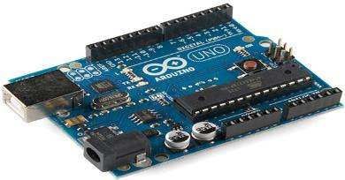

Fig 3: Arduino Uno Board

### Ultrasonic sensor HC-SR04

The ultrasonic sensor [Fig 4] is any infrasonic device's central component. Owing to the similarities of the function, the theory of the application of a radar or sonar can also be used to understand the procedure of the ultrasonic sensor. In other phrases, by measuring the time taken to transmit and receive the ultrasonic wave, it is possible to quantify multiple object-related details or obstacles that allow the wave to represent, such as the distance to the sensor, the height, the figure, etc. Towing turning radius affect the velocity (v) of the ultrasonic wave in a given medium; the structure of the medium and its temperature; explained in the given equation: [8]

**𝑣=340+0.6(𝑡−15) 𝑚⁄𝑠**

Where,

T, is temperature of the medium in ° C.

340 m / s is the sound frequency in the air that can be used instead of the ultrasonic wave frequency due to the limited working distance of the infrared sensor (less than 5m) in nature.

The HC-SR04 ultrasonic sensor parameters (Figure 2) [8] used in the configuration are summarised in Table 1. [9]

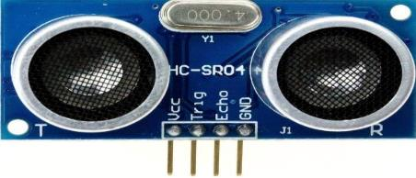

Fig 4**:** HC-SR04 ultrasonic sensor

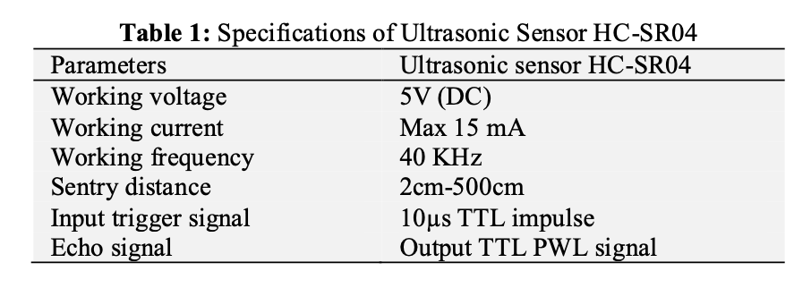

### Servo Motors

A servo system [Fig 5] [10]refers to a feedback control loop mechanism built to control one or more variables in such a framework. In the case of a servomotor that is assumed to [10]be a linear tubular reactor, acceleration and/or orientation are the parameters to be monitored. The servo motor system normally includes a special rotor, a sensor for error signal specifications and a regulator for location or range calculations.

The applications of servomotors are simply CNC devices, autonomous vehicles. In this function, in addition to both the Arduino board and the ultrasonic sensor HC-SR04 for location determination, a servomotor (which gives ±90 degrees of rotation) is used. [10]

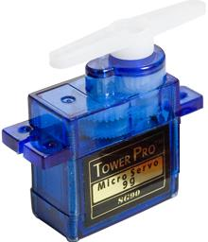

Fig 5**:** Servo Motor

### Voltage Regulator

Voltage regulator [Fig 6] [11] is an electronic controller programmed to keep a steady voltage level dynamically. Both current electronic voltage regulators work, apart from shunt regulators, by contrasting the real output voltage to any internal defined reference voltage. Every disparity is compounded and used to regulate the aspect of regulation. This generates a servo control loop of negative backlash.

The 78XX set of recent-terminal positive controllers are available in the TO-220 / D-PAK kit and with many fixed voltage levels, making them ideal in a broad range of applications where the output voltage is too low. Each type uses internal current limiting, radiant close down and safe security of the operating area, basically making it invulnerable. If sufficient heat sinking is given, they can produce output current exceeding 1A. [11]

While designed specifically as fixed voltage controllers, these instruments can also be used on discrete devices to achieve flexible currents and voltages [9]

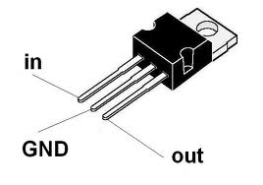

Fig 6:Voltage Regulator

## Software Requirements

### Using Arduino Software

The Arduino Integrated Software Environment (IDE) [Fig 7] [12] is a development framework written in Java, deriving from the IDE for both the language of coding processing as well as the programs of wiring. It is intended to incorporate programming which is uncommon with software creation for artists and other beginners. It provides a programming environment with syntax highlighting, brace matching, and code completion, and can compile and upload programmes with a single tap to the board as well. A "sketch" is a programme or code executable binary.

Arduino programmes are built of either C or C++. The Arduino IDE comes with a programme repository from the initial Wired platform named "Wiring," and making it much simpler for certain popular input / output operational activities. [12]

Subscribers would only have to specify two functions to allow an executive programme able to run cyclically:

Setup (): a function that runs once at the beginning of a programme to setup settings

Loop (): a constantly named feature when turned off by the board.

Open the programme Arduino IDE and pick the board that is in use. In order to pick the board:

* Go to Tools.
* Select Board.
* Pick the board used under the board.
* Go to Tools and the Port and pick the port where the Arduino is located.
* Write the code in the available space, and press on Compile. Click upload to upload the sketch to the Arduino board until the code is compiled.

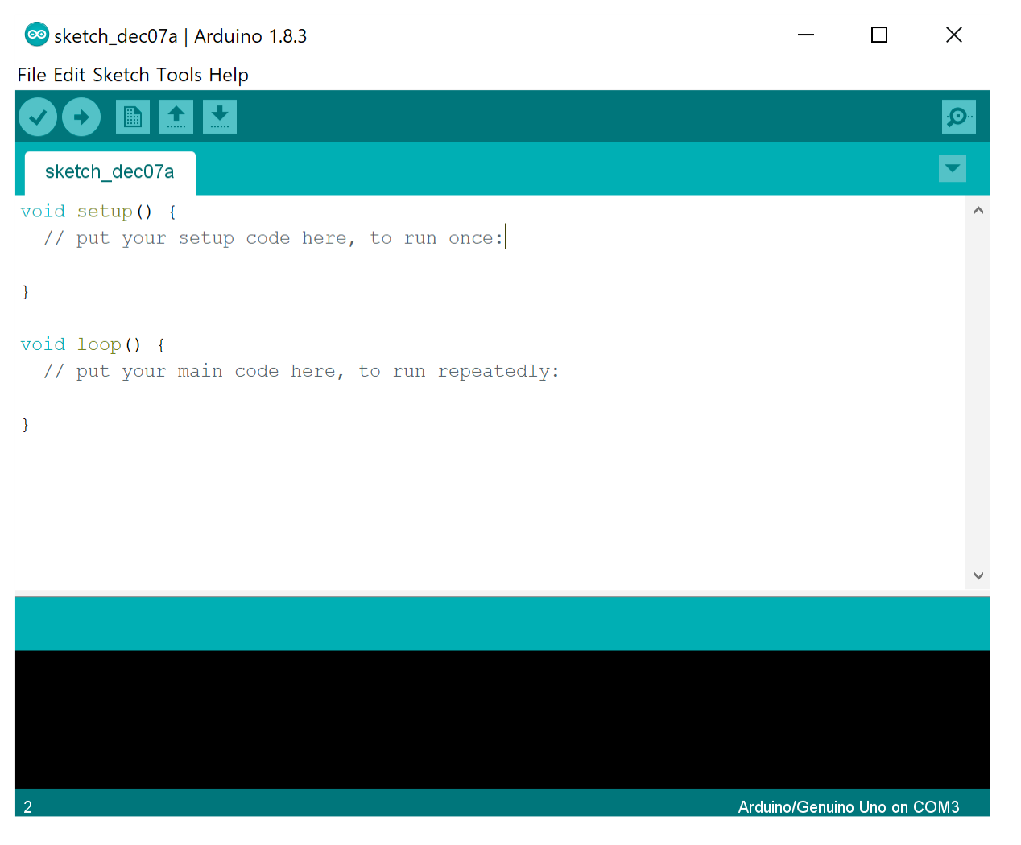

Fig 7**:** Arduino Software

# Functional Requirements & Non-Functional Requirements

## Functional Requirements

A substantial part of the technology supporting the internet is now deeply developed. We have near-universal requirements for the web, email, file sharing, and other internet technology. However, the Internet of Things has not yet achieved that consistency stage.

Fortunately, an IoT platform's technical specifications stay the same whatever technologies you select for each feature. Along with four major non-functional specifications, we will look at these functional requirements. This helps to include a good foundation for selecting a forum for IoT as per our needs. [13]

### Automatic Detection and Tracking

Automatic detection and monitoring is the mechanism by which the radar system identifies possible targets from among the collected radar signals, decides which detections may be from the same target over many scanning cycles, associates and filters those detections into a "verified" track for that target, and proceeds to monitor the target until it disappears from the receiver antenna.

Essentially, such software-implemented detection and recognition algorithms override what a person will do while viewing a radar monitor and determining which radar returns are equine targets.

In able to locate and monitor targets in their natural environment over a variety of functional conditions and to capture and record relevant target data, the tracker solution should be designed to perform the functions mentioned in the following subsections at the defined level of output. [13]

### Coverage

The radar should be able to provide the required coverage area which depends upon the size of the system prototype. The overall range and altitude at which the data provide operationally valuable meteorological knowledge should be supplied with radar data.[3]

**Threshold: Performance of WSR-88D**

* **Maximum** **range**: 46 m for reflectivity;

30 m for velocity and polarimetric variables

* **Maximum** **altitude**: 70ft

### Picking up Signal

Radar detectors use a pulse generation transmitter to trace such electromagnetic radiation from the system, and alert the user to notify when a signal is identified.

A radar signal / data processor that collects and converts the properties of the reflected signal from the radio signal to classify the items, theirs ranges and the frequencies.

The radar should be able to pick up the radio signals from the artifacts within the range of the system built. Also, it should transmit the data to the output screen (Fig 8) to locate the position of the object. [14]

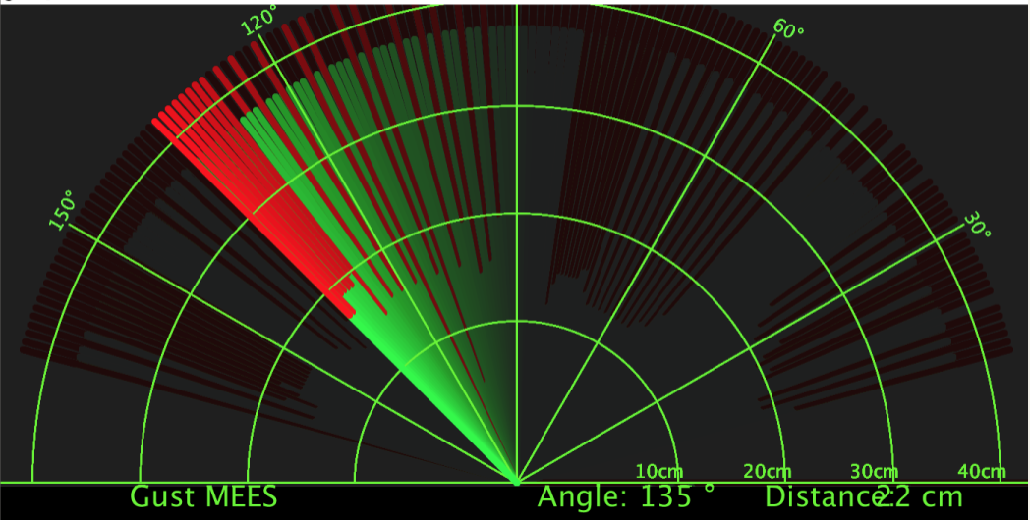

Fig 8: Radar output screen

### Frequency

Frequency is concern of first priority when developing any radar system. For same

size antenna, the greater the emitted radar frequency (i.e., the shorter wavelength)

the:

* Greater efficient strength, which translates into more distant identification of goals.
* More precise goal azimuth determination.

**Threshold**: Performance of WSR-88D (S-Band, ~10 cm)

The best alternative is the WSR-88D wavelength of ~10 cm as it promotes an effective range of 460 km because of reduced amplification. This wavelength means that vital coverage is provided by each radar. Frequency often influences target scattering properties and cluttering properties (e.g. size), but trade-offs are dynamic in nature and rely on a variety of variables outside the reach of this study. [9]

## Non-Functional Requirements

### Reliability

Restrictions on the software's runtime performance could be deemed under 2 distinct topics:

* **Availability**- Is the device that is accessible for use as end-users need it.
* **Failure rate**-How much does the project fail to provide the service that people expect?

### Performance

The performance of this particular system describes the system’s operation capabilities and constraints that enhance its functionality. Some of its aspects as a non-functional requirement could be as:

* How fast does the system return results?
* How much will this performance change with higher workloads?

The radar system's performance can be assessed as follows:

* the highest range with which a threshold of a set length can be seen,
* the precision of its assessment of the designated target in spectrum and angle,
* its ability to distinguish between a target and another,

Bandwidth requirements can range from 6 Kbps to 128Kbps in the case of voice transmission, and network load can range from 50 Kbps to 6 Mbps for video playback. The real-time time-series radar data demand for bandwidth is in the range of tens of Mbps to hundreds of Mbps.

### Security

* Accessible permissions for data sources can only be modified by the data administrator of the system.
* All data attributes must be supported every 24 hours and data backups must be kept in a protected location which isn't in the same control system.
* All external communication must be secured here between database. the data device and the server [9]

### Usability

* Concerned with the UI and end-user device interfaces being defined.
* Effective user manuals, helpful error notices, assistance facilities and reliable interfaces boost usability

# Methodology

## Agile

Agile consists of a collection of ideals and concepts that can be worked on by people and teams to improve their apps. Agile is not a technique, a single way, a system or a mechanism of doing things. It is a set of principles that helps you to be successful with what you do, based on three foundations, namely accountability, examination and transition.

Traditional project management focuses on the iron triangle (Scope, Expense and Time), Agile focuses mainly on the fourth parameter, which is value, while balancing cost, time and scope, Agile emphasises on value creation.[15]

Here are just a few reasons I went with agile:

**Agile Believes in Adaptation:** Adaptability is the one key skill that helps us to remain important in this fast-paced environment as individuals or organisations. Adaptability was the perfect aid for humanity to develop from the Stone Age to the present. For each of us, the importance is felt more than at any time.

**Agile adjusts to change:** Organizations struggle in markets across the spectrum as typical business and management strategies avoid operating in the face of accelerated change. For that reason, many organisations have opted to implement agile management strategies that allow them to react and adjust to market while infusing the process of providing value to the consumer with technological innovation.

**Agile Focuses on Value Optimization**: Agile focuses on what is necessary, the greatest possible investment, by prioritising and deferring obligations, to offer the highest value to consumers. Agile specialises in inspection and change instead of anticipating, and this helps organisations and departments to respond to circumstances based on optimum benefit delivery.

## Kanban

This, not being my first time doing solo project, and understanding my greatest competitiveness adversary is always myself, I wanted to make completely sure that I can use my resources at 100% potential. Hence, the system I came up with is just a set of agile garden-variety ideas tailored to my needs, Kanban, as a solo project.

The theory is that it's so much about flow and kanban really promotes flow well. Throughout the day I use a basic personal kanban, with just a collection of states [Fig 9] that suit for me (Ideas, Backlog, In Progress, Verify, and Done) and collection my own WIP limits [Fig 10] for each phase.

[16]

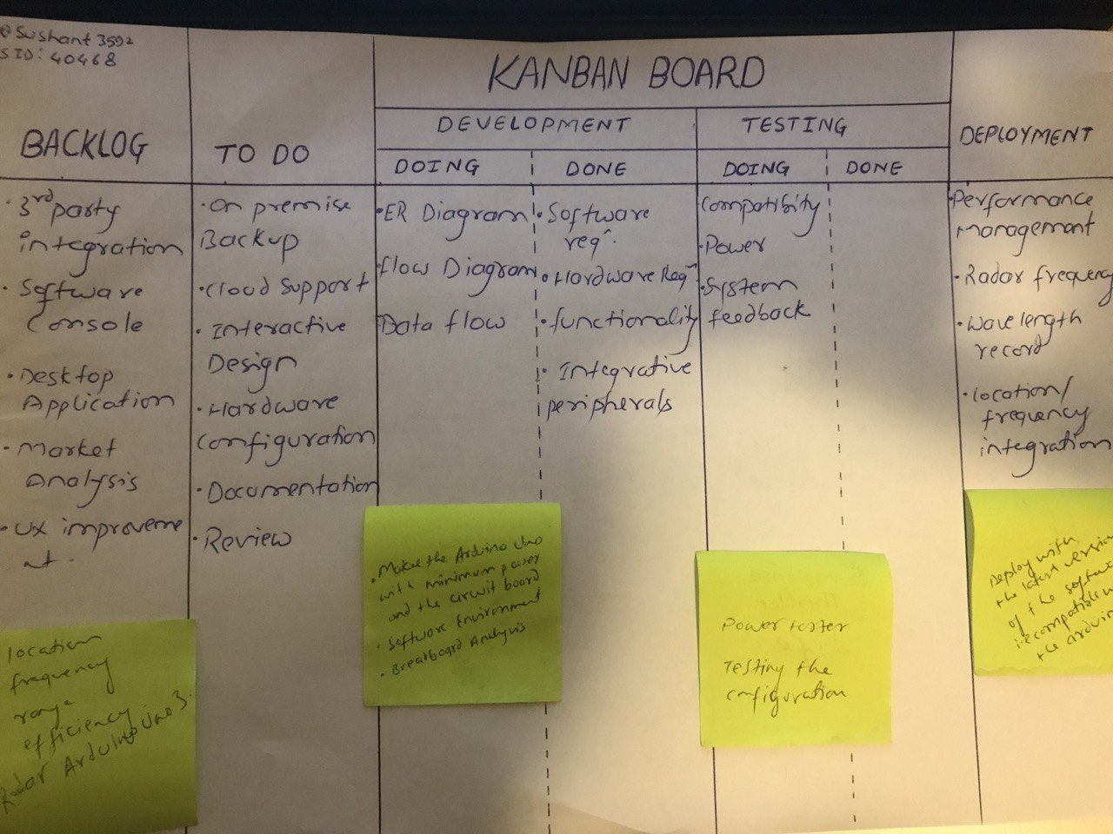

Fig 9: **My Kanban Board with different states**

I usually defined the short sprints for the tasks achievable. I would try to have a friend on the hook who I might call when I was in distress and talk about the problem with the code. 90 per cent of the time, just the act of describing a problem out loud gives an answer to my mind. Keeping a final output backlog which is just the compilation of all the things you plan to complete with this inventory at some time.

Based on an approximate determination of the concentration of hours I'll spend on it, in intervals of 2 or 4 hours, I add points to my booking. With practise, my assessments got higher. Each deliverable should be inserted into the finished product and not crack or leave something else in a state of disarray.[16]

**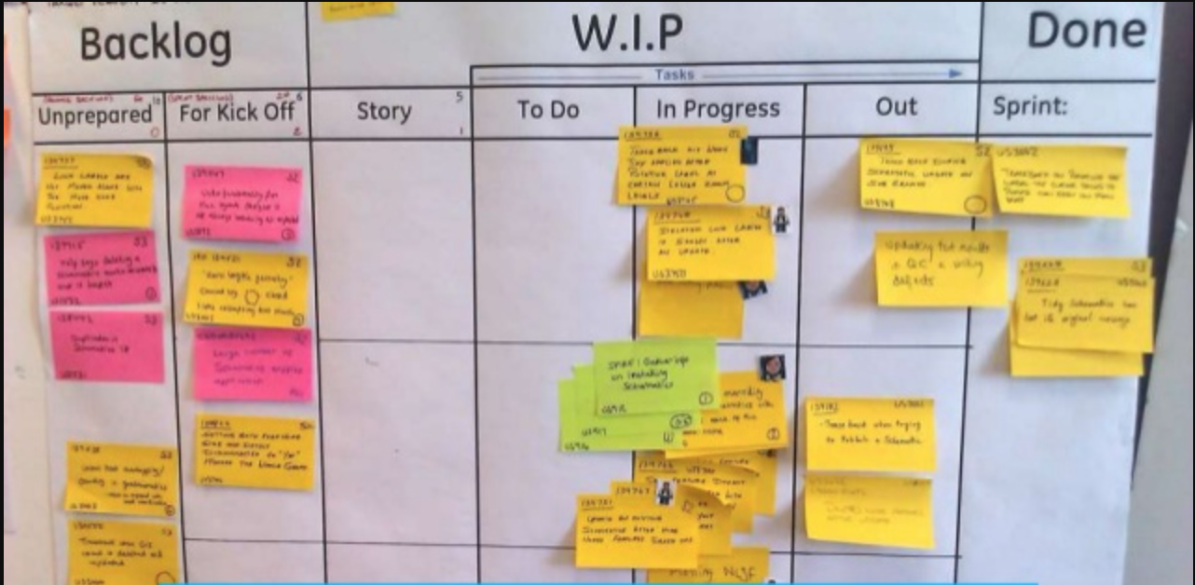**

Fig 10**: Kanban board with W.I.P flow**

I don't really have colleagues or supervisors, just oneself, there's someone I need to sit in front of me to remind me about what I was dedicated about. This has been the most essential component for me, maybe. I hold that in front of my monitor so that I can't miss it as a website might do. I've probably used a dozen web-based methods, even if I'm the only one, I can't help myself to be happy with either of them. You have to disciplined with this one.

# 

# Scope

Below is a list of each component of the Project Scope Statement, and a description for each.[18]

Product Scope Description: Upon the completion of the project, we will have an ultrasonic senor embedded radar system that is capable of detecting objects in a defined range, built on Arduino.

Deliverables: This project has numerous deliverables to satisfy the project scope. The project has to deliver the accurate range of the detected object, has to be power efficient. The coverage and the frequency of the system should be optimised for better result.

Acceptance Criteria: There are several acceptance criteria’s that the project must meet in order to pass the project objective. The radar system must function properly without any hassle and for a longer period of time. The system can detect the object in the range of 40m, given the size of the prototype of the project.[1] The radar system should be able to detect the object every single time with absolute accuracy**.**

Project Exclusions: To make the project scope clearer and more concise this section includes the exclusions that are included in this project. The project shall not detect objects too far away. The radar system will not be wireless for this project but has the capability to upgrade to wireless system.

Constraints: There are certain factors that may constrain the project completion. For example, the project is dependent on the arrival of the hardware components on time. The software used for this specific project runs only on the MAC environment. This project has a definite budget of AUD $90 with no possibility of an increase.[18]

Project Assumptions: The project requires an object (to detect) and power supply to power the system. It is assumed we will have those supplies.

# 

# 

# Feasibility Analysis

Given the wide application of radar system in various industries, the idea of this project very viable and it is that the ensured project is legally and technically feasible as well as economically justifiable. The proposed system plays a great role in the development of some crucial and exciting innovations which makes this project worth the hard work and the investment.[2]

A project is feasible if its design meets the technological, legal, financial and other requirements of a state, area or particular location. Feasibility is a general prerequisite for any project which should be closely watched. In addition, many alternatives could be viable, as reported. Some of the aspects of the feasibility analysis and how they meet the project requirement are briefly described below:

## 

## Technical Feasibility

Considering the technical feasibility of this project, we have all the required technology and the resources available. The technical resources for this project are programmer, tester and debugger. The technology used in this project are the latest Arduino software and the ultra-sonic sensor.

The technical hardware requires breadboard, voltage regulator, jumper cables, Arduino UNO board and a senor which are easily available. After establishing all these technical components, I also considered the monetary aspect of the project that includes the technical cost and is just within the budget. Hence, developing this particular project requires less investment and is technically possible.

## 

## Operational Feasibility

After the development of this project, it can be implemented in various sectors. While reviewing the tech used in defence, be it Military, Marine or Air Force and now also used in car models using smart features such as autonomous driving, smart parking, crash avoidance during driving, etc., the concept of having an Ultrasonic RADAR occurred to me. Such implementations have recently been used in the self-parking vehicle systems introduced by AUDI, BMW, etc. Also, the new Google driverless vehicles like Lexus.

Because of those reasons, this project has management support and the system is very much in demand for the business practise as it has the capability to replace any such existing system, since it can help the automatic sensor field drastically. The users will be affected by the system in a considerable way and the business can also profit.

## 

## Legal Feasibility

The project is legally feasible as there are no contracts, obligations, infringements or other legal traps.

## 

## Economical Feasibility

The benefits of project when this implemented on a commercial stage will exceed the cost applied to the project. Hence, the system can be considered economically feasible.

In terms of economic viability, a cost-benefit study is carried out in which the potential costs and advantages are measured. Economic research is used to assess the feasibility of the planned scheme.

**Performing Cost Benefit Analysis (CBA)**

Cost for the proposed system (figures in AUD Thousands)

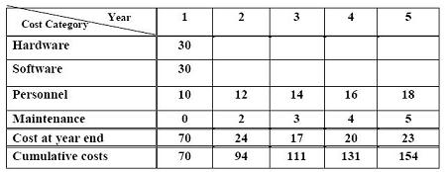

Fig 11: Cost for the proposed system

Benefit for the propose system

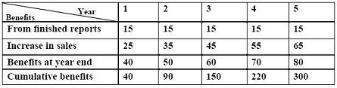

Fig 12: Benefit for the propose system

Profit = Benefits - Costs  
= 300,000 -154,000  
= AUD 146,000

Since we are gaining, this system is feasible.

# 

# Risk Constraints Analysis

The risk factors of this project are enlisted (but not limited to) below:

## Budget

The project may be halted due to lack of sufficient budget required to successfully complete the project.

## 

## Policy

In accordance with the college’s project completion deadline policy, a field trip that is planned as a part of the project has to be cancelled.

## Scope Creep

The project may not be completed within time or as expected if the scope statement alters from the original scope.

## Safety

The project plan to test the system is abandoned out of concern that it’s not safe inside the campus because of the electrical appliances used and just in case.

## 

## Scope

The scope of the project that was launched in early July must be severely curtailed in order for the project to be completed by the end of the semester.

## Time

A series of failed test may delay the system completion.

## Training

A planned test of the system is placed in jeopardy because of the lack of inadequate experience with the new version of the software released.

# 

# UML diagram and descriptions

## Use Case Diagram

In light of the large complexities of radar software, this project uses UML modelling technologies to analyse the functions and architecture of radar software. On the basis of the specifications of the radar programme, it can be recognised that the operating system includes remote control, parameter selection, track monitoring and computer managing.[21]

The radar management system may be upgraded to the following features: remote control, parameter configuration, track administration, equipment management. In the field of radar remote monitoring, the monitoring of radar equipment is primarily carried out over the network. Setting the reference is used to control the related parameters in the radar. Track radar track control. Equipment control is used to handle radar equipment [21]

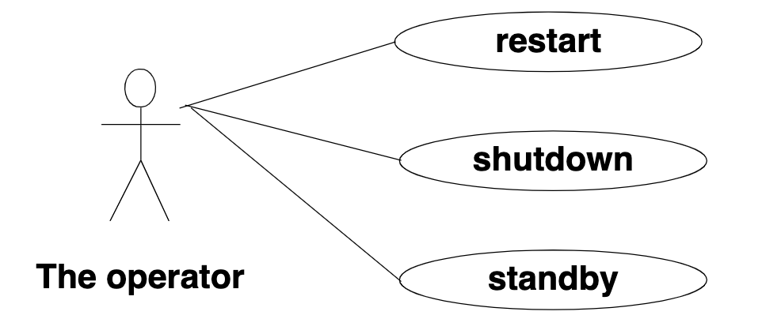

Fig 13: Use Case Diagram for the operator

Parameter management is the management of the parameters of the radar equipment. The functions described in this module include: parameter inclusion, parameter adjustment, parameter display and parameter deletion. Figure 14 demonstrates the use of case diagram parameter control.[21]

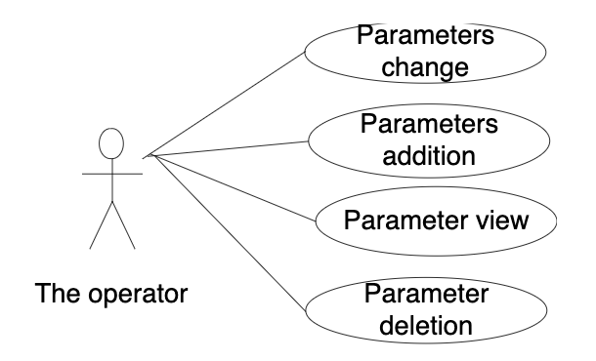

Fig 14: Parameter Setting Use Case Diagram

Track control is used to track display, track extension, track adjustment, and manual track entry management. Figure 15 is a case diagram for track management.

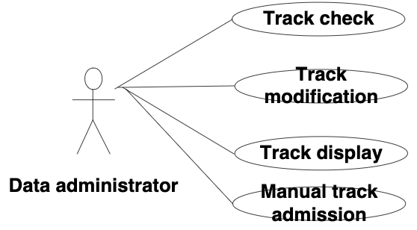

Fig 15: Track Management Use Case Diagram

Radar management requires a vast range of sensors such that the features of system management are added for such task. Operations include system inclusion, system alteration, device tests, and device elimination.[16]

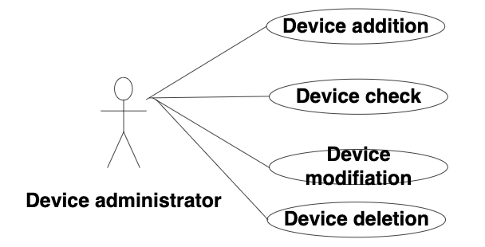

Fig 16: Device Management Use Case Diagram

## Class Diagram for GUI sub-system

The object type of the radar project describes the object that it finds, such as altitude, target / range and angle / direction of the object's location. Distance) (method), (angle) (method, position) (method takes the necessary attribute, such as distance, angle, and makes it possible for the GUI to simulate.[16]

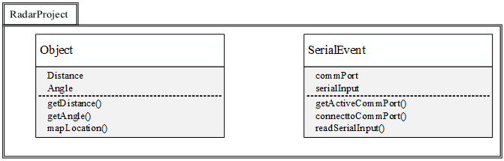

Fig 17: Class Diagram for GUI sub-system

## 

## Class Diagram

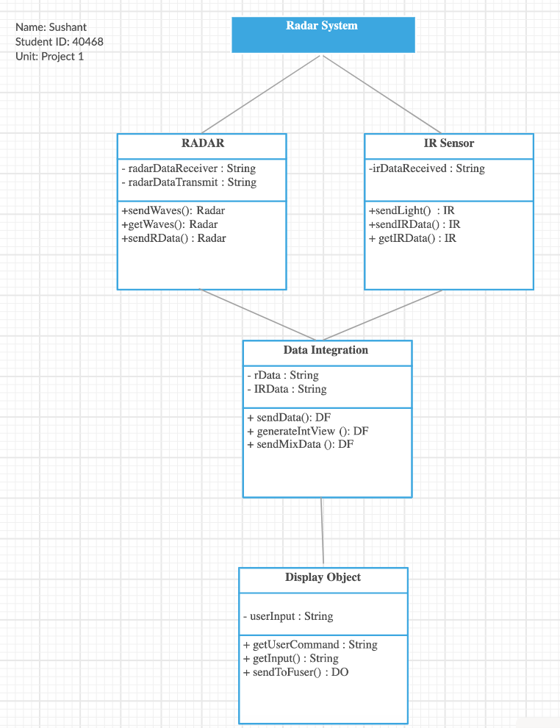

Fig 18: Class Diagram for the Radar System

UML modelling class diagrams (Fig 18) are used for the related functional design and database design in order to promote the implementation of the framework. Thanks to the above architecture, it is finally ready for the production of radar applications. [16]

# 

# Executive Summary

Sensors are instruments that calculate physical properties and translate the values into signals that can be perceived by an operator for the purpose of acquiring or reacting with actions. Sensors such as cameras and radar detectors have proved to be realistic sources of learning which can be used to ensure the safety and welfare of society in particular, and to actually fix circumstances of crisis. Sensors are networked, making it possible to gather knowledge, interpret it and make it available to professional decision-makers.

## 

## Social Aspect

There are various social aspects of this project one of the most important being its effect on the economy of the country at whole which results in the lifestyle of its citizen through budget and tax factors. The Asynchronous radar safety regulation can be an innovative and reliable way of controlling traffic speed, reducing crashes and accidents and combating the tremendous economic strain on society. The cost-effectiveness of the initiative takes on particular importance and relevance when contemplating existing and future government budget restrictions. [21]

Dangerous speed is among the significant issues facing by the motorised countries in terms of road safety. In 2003, dangerous speed amounted to 31 per cent of all deadly crashes, resulting in a loss of 13,380 lives in the US alone. The financial consequences of speeding is enormous. According to NHTSA, the loss to the American corporation of dangerous speed-related accidents tops US$ 40 billion every year.[21] In response, automatic radar traffic control systems have been adopted in several countries.

## 

## Ethical Aspect

The advancement of radar technology is primarily directed at impacting the privacy and protection objectives of society. However, the ultimate social effect is not solely determined by the technological specifications and their expected usefulness.

We analyse this development as a socio-technical framework, which implies that the introduction of technology into social and ethical systems is of fundamental importance to its effect: What information will be analysed and by whom? Who's going to handle the information? How are the data going to be used? Who sets the objective of functionality while the device is built to fulfil various objectives? It's assumed that the synchronisation aspect makes these issues much more complicated and vital to the accomplishments of modern technology.[21]

# 

# Architectural Diagram

The architecture diagram will help system designers and engineers envision the high-level, overarching configuration of a system or programme to ensure that the system serves the customers’ needs. You may also use architectural diagrams to explain patterns used in the design. It's sort of like a roadmap which can be used as a reference for the ease of debating, enhancing, and pursuing the squad.[22]

System developers need proposed system diagrams to comprehend, specify and discuss effectively about the network architecture and requirement specification which the system wants to support. It is a simple tool that can be used during the design process of the scheme, allowing stakeholders to understand the design, address improvements and convey goals.[22]

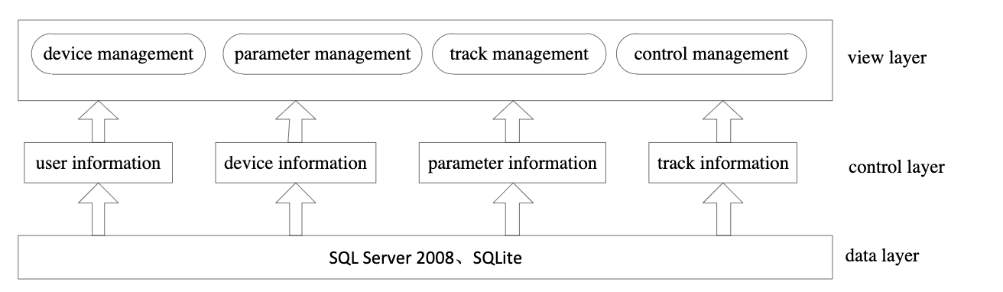

Fig 19: Architectural Diagram of the system.

Based on Figure 19, the interface layer functions entail data communications, parameter management, path coordination and monitoring management. The connexion of this layer can be embellished using Component Factory. Krypton, Toolkit. The duties of the control layer are patterns of social, system information, configuration data and route details. SQLServer2008 and open source SQLite database are primarily used in data layer for storing data processing.

The above architectural diagram shows the components working at the view control and the data layer to transmit the various information from each layer to another in order to run the system smoothly. This diagram is helpful from a developer’s point of view as this gives an effective idea about the data transmission and communication in the system. Here the database in use is SQL Server.

# 

# Flow Chart

## Project Flow Chart

In managing projects, a flow chart is a graphic guide for understanding the process used to plan the project. The chart demonstrates the interrelated and concurrent phases over the course of the project.

Here, I have included the project flow chart at various stages and the works carried out on those phases. The major phases of this project development were: Initiation, Planning, execution, monitoring and controlling and closing. The work done during those phases are illustrated in the given flow charts for better and quick understanding.

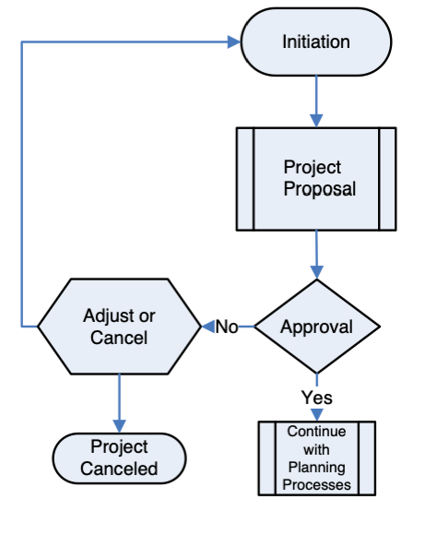

Fig 20: Project Initiation Phase

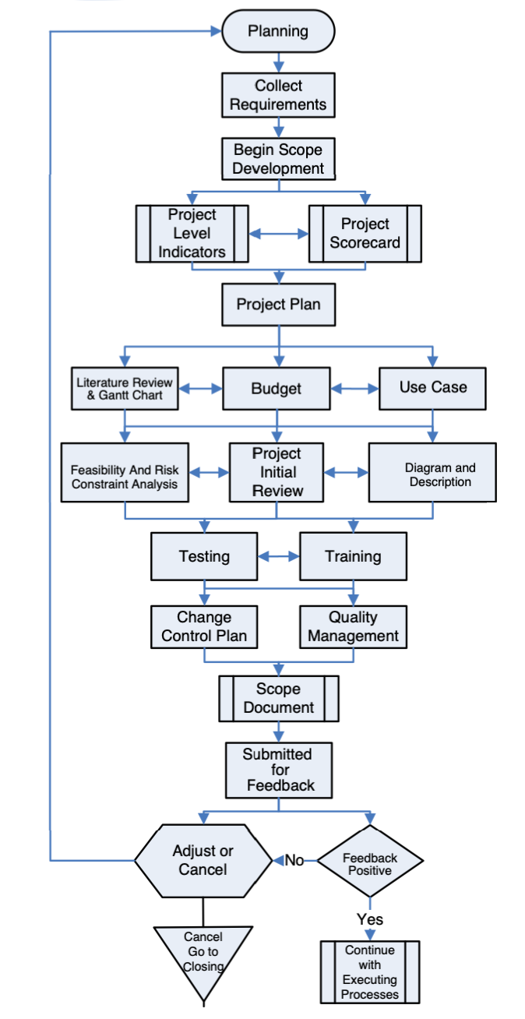

Fig 21: Project Planning Phase

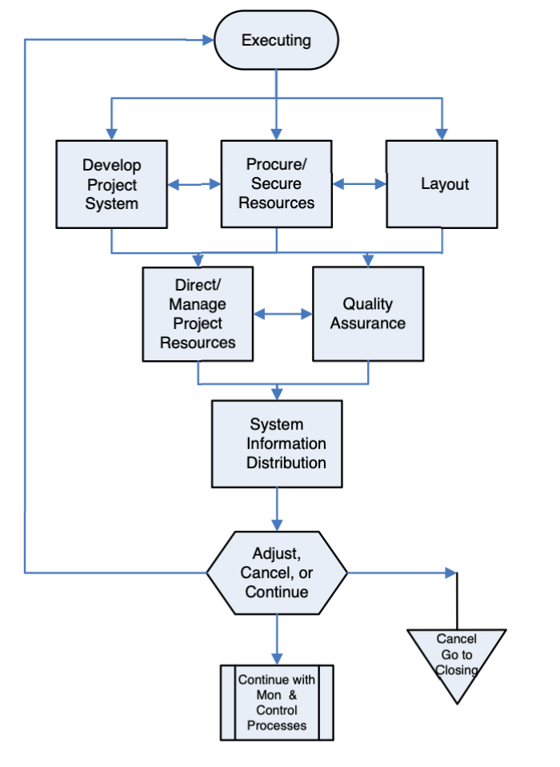

Fig 22: Project Execution Phase

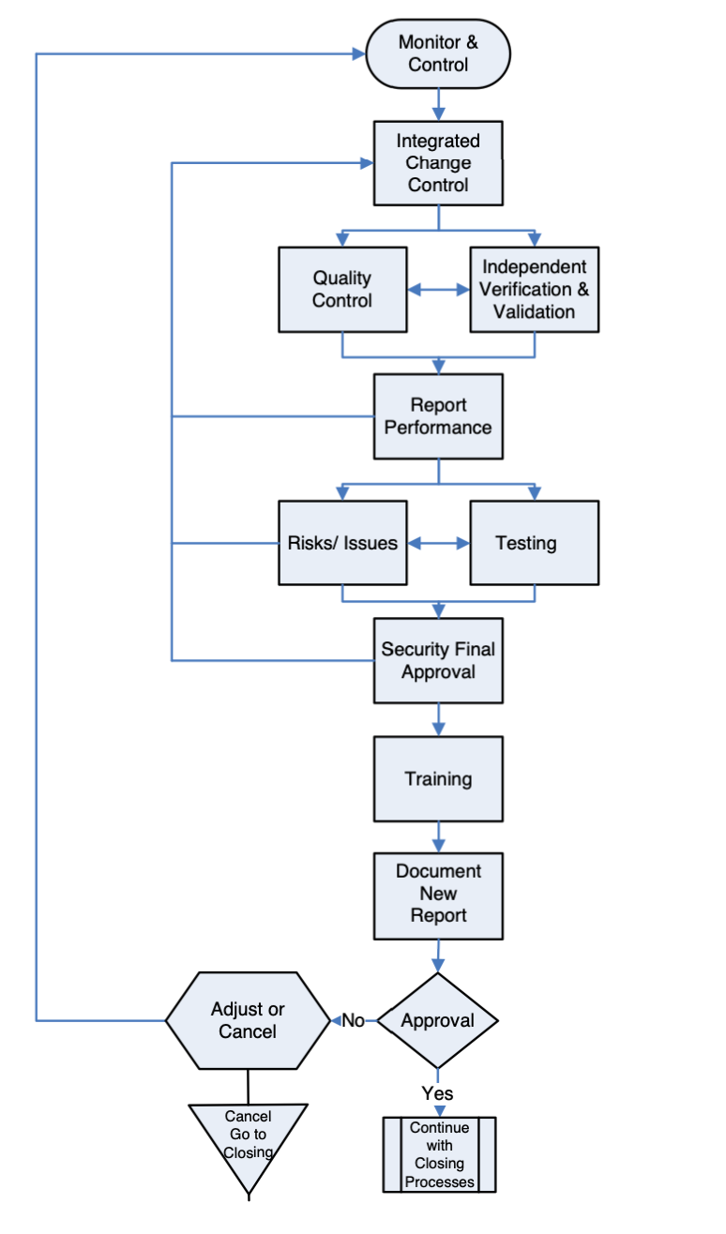

Fig 23: Project Monitoring and Controlling Phase

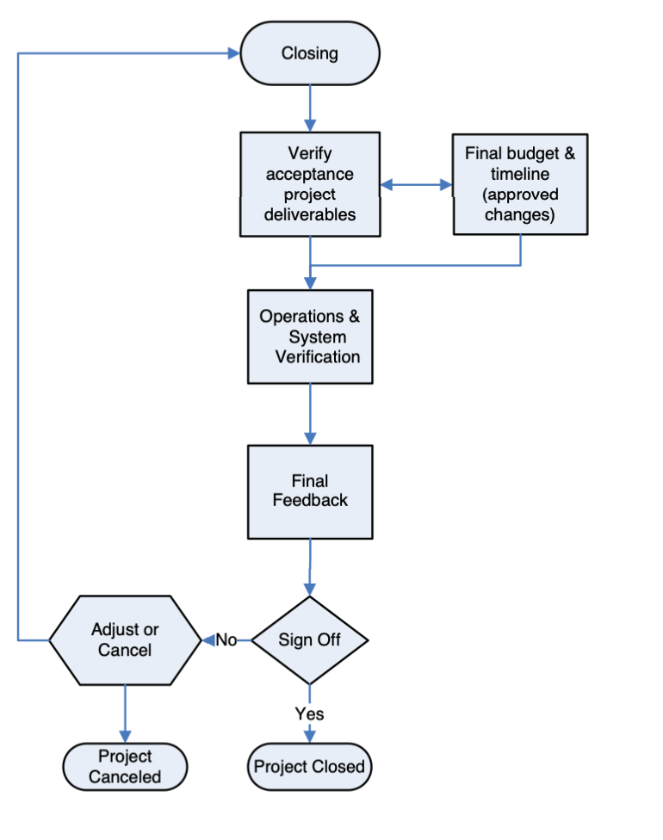

Fig 24: Project Closing Phase

## System Flow Chart

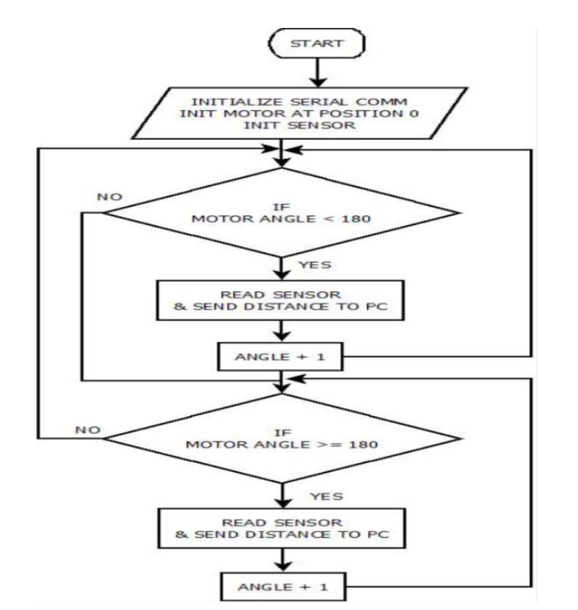

Fig 25: System Flow Chart

The flow chart (Fig 25) above illustrates the working and course of action of this system. As it is observed, the device begins with start, i.e. when an ultrasonic sensor senses an object or just doesn't sense an obstacle, at any situation the circuit feeds the data in the processor while the servo continues spinning continuously.[23]

As soon as some obstacle / object is sensed by an ultrasonic sensor, the data is automatically interpreted by the processor and transmitted to the IDE which is displayed on the computer display. Here the program ends with the approximate distance of the target from the device with the angle at which it is located.

# Circuit Diagram

The architecture of the hardware device circuit, shown in Figure 26, was constructed using a fritzing setting. The relation between the respective electronic parts is seen. In the diagram, the activation pin of the ultrasonic sensor is linked to the pin D8 of the Arduino micro-controller, the echo input is connected to the pin D7 of the micro-controller and the control line of the servo motor is linked to the pin D6 of the micro-controller. [23]

The VCC pins from both the servo motor and the ultrasonic sensor are wired to the 5V pinout of the Arduino whereas the GND pins from both the ultrasonic sensor and the servo motor are linked to the GND pinout of the Arduino.

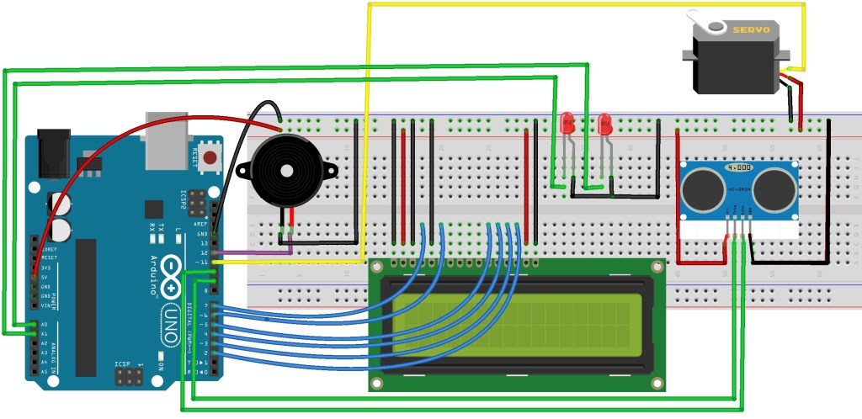

Fig 26: Circuit Diagram

Following are the connections made into the Arduino Uno Board:

The Ultrasonic Sensor HC-SR04 is connected to the pin numbers 10 and 11 respectively on the Arduino Board.

TrigPin = 10.

EchoPin = 11.

And the servo motor to the pin number 12 on the Arduino Board. Fig 29 [23] shows circuit structure for the project.

MyServo = 13.

# Block Diagram

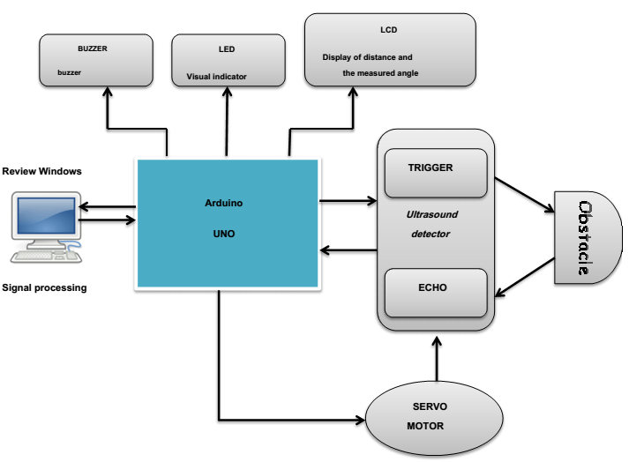

Fig 27: Block Diagram of the System

Here, the workflow of this radar system could be seen in the block diagram above (fig 27). The sensor can identify the barrier and assess the position of the event and it’s range from the radar. The servo motor is continuously rotating back and forth, attempting to make the sensor move. The data collected shall be encoded and transmitted to the IDE processing where it reflects on the display. [23]

All of this process is conducted by the Arduino microcontroller from the movement of the servo, the data gathering from the sensor, the data is fed to the encoder to be transmitted to the monitor.

# Conclusion

In this report, a lab-scaled radar system was developed and deployed using an Arduino, a servo-motor and an ultrasonic sensor. The developed device is capable of reading the range of the objects and the angle of the instance and translating this data into visually represented data. Device output tests at its level with other devices, when it accurately records any obstruction it faces along its direction and gives an average range of the object.

This device can be uniquely tailored to accommodate different applications, including being fitted in cars to assist in reversing, being able to determine the water level in a well, or reservoirs, etc. The GSM techniques can also be used for effective remote control. The approach can also be advised for use in passages such as train or car tunnels to provide signals in the event of emergencies.

The range of the device depends on the range of the Ultra-Sonic sensor used. The HC-SR04 Ultra-Sonic sensor, which ranges from 2 cm to 40 cm, is shown in this device.

# References

|  |  |
| --- | --- |
| [1] | Q. A. M. ,. M. S. Mohanad Mahdi Abdulkareem,  "A Short Range Radar System “Rangefinder”," *Rangefinder.* |
| [2] | A. Dutt, "Arduino based RADAR System, Munich, GRIN Verlag.," 2014. |
| [3] | S. T. S. R. Srijan Dubey, "IMPLEMENTATION OF RADAR USING ULTRASONIC SENSOR,"  *Indian J.Sci.Res,* 2017. |
| [4] | A. Tedeschi and F. B.-. Stefano Calcaterra, " Ultrasonic RAdar System (URAS),"  *Arduino and Virtual Reality for a Light-Free Mapping of Indoor Environments,* vol. 17, no. 14, July 2017. |
| [5] | E. C. S. K. T. S. T H Nasution, "Design of river height and speed monitoring system by using Arduino,"  *10th International Conference Numerical Analysis in Engineering ,* 2018. |
| [6] | S. H. S. M. U. A. R. J. I. A. Syed M Taha Saquib,  "Wireless Control of Miniaturized Mobile Vehicle for Indoor Surveillance,"  *ICSICCST 2013 IOP Conf. Series: Materials Science and Engineering.* |
| [7] | "Arduino Uno," Aduino, [Online]. Available: https://www.fierceelectronics.com/sensors/  what-ultrasonic-sensor#:~:text=An%20ultrasonic%20sensor%20is%20an,sound%20that%20humans%20can%20hear)..  [Accessed 27 09 2020]. |
| [8] | "UltraSonic Sensor," fierceelectronics, [Online].  Available: https://www.fierceelectronics.com/sensors/what-ultrasonic-sensor#:~:text=An%20ultrasonic%20sensor%20is%20an,sound%20that%20humans%20can%20hear)..  [Accessed 27 09 2020]. |
| [9] | A. Dutt, https://books.google.com.au/books/about/  Arduino\_based\_RADAR\_System.html?id=8bzmAwAAQBAJ&redir\_esc=y. |
| [10] | "Aduino," arduino hub, [Online].  Available: https://create.arduino.cc/projecthub/arcaegecengiz/  how-to-use-servo-motors-with-arduino-b02bed. [Accessed 27 09 2020]. |
| [11] | "Instructable," Instructable, [Online]. Available: https://www.instructables.com/id/  5V-Voltage-Regulator/.  [Accessed 27 09 2020]. |
| [12] | "Arduino Software," Arduino, [Online]. Available: https://www.arduino.cc/en/main/software.  [Accessed 27 09 2020]. |
| [13] | Y. A. P, "RADAR SYSTEM USING RDUINO.pdf,"  *Radar System Using Arduino: Prof. D.A.Ghoghre , Ahire Dhanshri , Ahire Priyanka,* p. 4. |
| [14] | Unknown, "Risk And Constraints," [Online]. Available: chrome-extension://oemmndcbldboiebfnladdacbdfmadadm/http://www.eduproject.org/monographs/  EduProject\_  Monograph\_Hutchison.pdf. |
| [15] | M. M. W. H. Xia Houshi, "Research on Modeling Method of Radar Test System Based on UML and Petri Net[J].," *Journal of Instrumentation, 2009, 30(1).* |
| [16] | Z. N. L. Y. He Lei, "Modeling of airborne radar based on UML[J].," *Journal of System Simulation, 26(5),* 2014. |
| [17] | L. Hai, "Radar software design built on real-time UML[J].," *Modern Radar,* 2006. |
| [18] | Brighthub, "BrightHub," [Online]. Available: https://www.brighthubpm.com/project-planning/57950-example-and-evaluation-of-project-scope-statements/. |
| [19] | EEWEB, "Radar and its applications," [Online]. Available: https://www.eeweb.com/radar-types-its-application/. |
| [20] | NHTSA, "Speeding," [Online]. Available: https://www.nhtsa.gov/risky-driving/speeding. |
| [21] | EDRAWSOFT, "Architecture," 2020. [Online]. Available: https://www.edrawsoft.com/architecture-diagram.html. |
| [22] | ProjectHub, "Arduino Board," 2020. [Online]. Available: https://create.arduino.cc/projecthub/muhammad-aqib/arduino-button-tutorial-using-arduino-digitalread-function-08adb5. |
| [23] | S. Hameed, N. J. D. R. and F. S. , "Arduino," [Online]. Available: chrome-extension://oemmndcbldboiebfnladdacbdfmadadm/https://www.3ciencias.com/wp-content/uploads/2019/01/Art\_14-1.pdf. |

# Appendix

**Feedback Response Report**

|  |  |  |  |
| --- | --- | --- | --- |
| Appendix A (Assignment 1) | | | |
| S. No | Comments Received | Comments Response | Page Number |
| 1 | Table of contents need to be fixed and includes the sections discussed in Assignment 1 only. The full table of contents is expected in the final report. | Table of contents fixed comprising the first assignment only. | 0 |
| 2 | Literature review is too short and lacks referencing. | Literature review explained in long with proper referencing. | 4,5 |
| 3 | Gantt chart has been created based on the assignment requirements not different phases of the project. Gantt chart elements need to be unique for your project and not a general template | Gantt chart prepared outlining the different phases carried out during this specific project. | 6 |
| 4 | References must be styled as per IEEE | References revised as per IEEE. | 37,38 |

|  |  |  |  |
| --- | --- | --- | --- |
| Appendix B (Assignment 2) | | | |
| S. No | Comments Received | Comments Response | Page Number |
| 1 | There is no table of contents in your report | Included table of content | 0 |
| 2 | The functional requirements need to specify what your system performs  **Power, scan period and power** are not truly representing the function of the system and need to be re-written. | Functional requirements rescripted containing specific functionalities only re-written. | 13,14 |
| 3 | Some of the non-functional requirement are not elaborated | Non-functional requirements recapitulated. | 14,15 |
| 4 | In methodology since you are using agile, it's better to explain a bit about agile methodology | Agile methodology description included in the report | 16 |
| 5 | reference table needs to be fixed to show reference numbers properly. | Reference table fixed as per IEEE | 37,38 |

|  |  |  |  |
| --- | --- | --- | --- |
| Appendix C (Assignment 3): | | | |
| S. No | Comments Received | Comments Response | Page Number |
| 1 | In feasibility analysis, it's better to discuss about the legal, technical and economical feasibility analysis (as mentioned in report) and specify the requirements that are met in this project and hence make this project feasible. | Feasibility Analysis re-written depicting the legal, technical, operational and the economical feasibility analysis and how the met the project requirements. | 20,21 |
| 2 | Not sure if "Grade" can be considered as a risk for this project. | “Grade” risk is replaced by “Scope Creep” | 22 |
| 3 | In parameter setting, are you specifying a particular parameter, if yes mention the parameter in the diagram | We are not specifying any particular parameter at the moment. That is to be done after the prototype is ready. | 23 |
| 4 | You may need to edit the caption for Fig 6 | Fig 6 Caption Edited  (Its Fig 16 in this report) | 23 |